Session-15

Create a workspace for all Angular workspace

1. Create a folder for example “Angular-First”
2. Go to the “Angualar-first” Directory using the below command

Cd Angular-first

1. Third step is given bellow

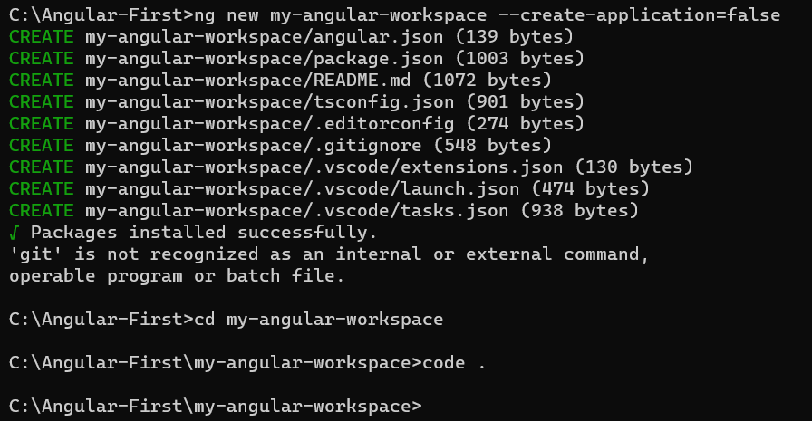

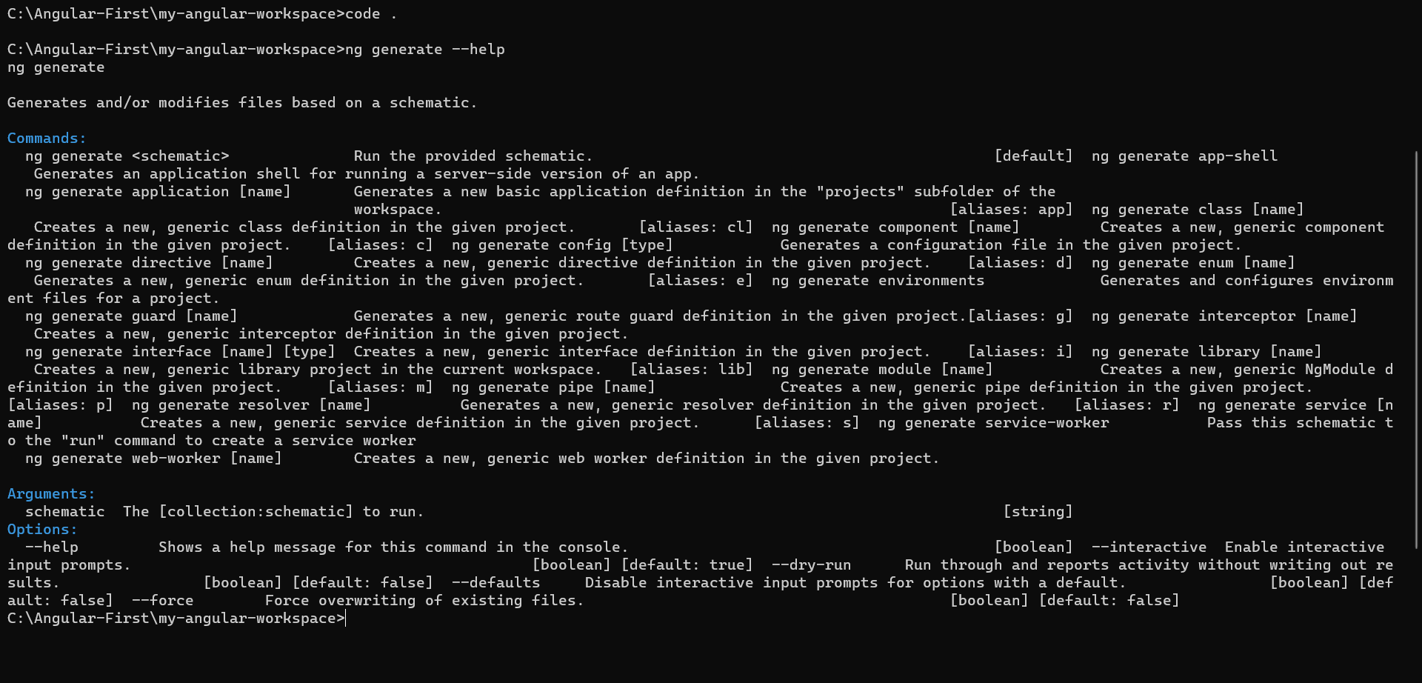

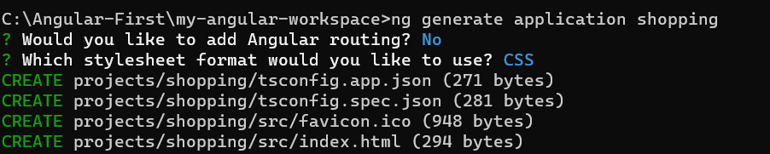

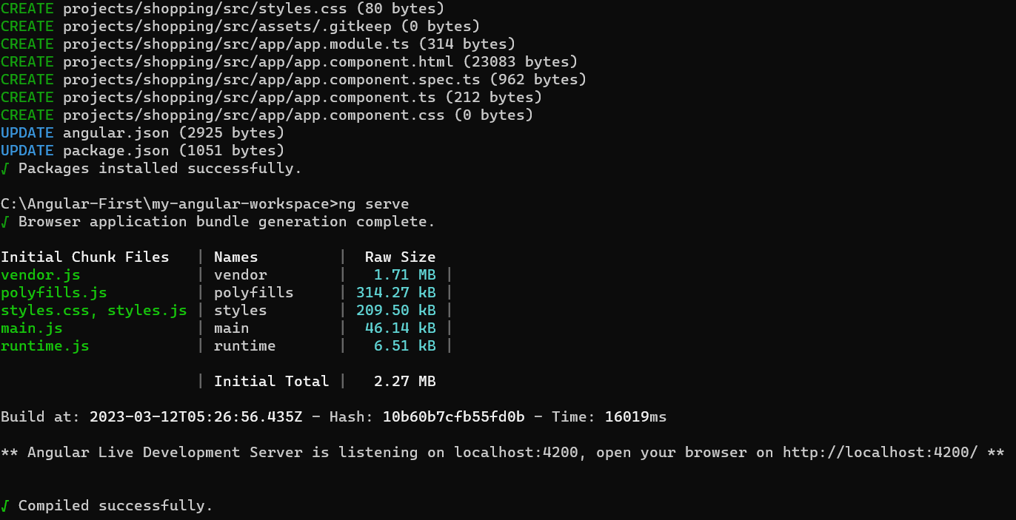

Session 16 it very imp for component

[Architecture Overview - ts - GUIDE (angular.io)](https://v2.angular.io/docs/ts/latest/guide/architecture.html)

Session 17 is going on